**CIS 572 Object Oriented System Design**

**Backward Tracing**

For

**Adding Provider (Manage Registration)**



Submitted to:  Mr. Thomas Steiner

Submitted by: Tejaswi Dasyam

UMID 46593296

**Table of Contents**

CRC CARD **3**

STATE DIAGRAM **3**

DFD **3**

CLASS DIAGRAM **4**

SEQUENCE DIAGRAM **5**

COMMUNICATION DIAGRAM **5**

ROBUSTNESS DIAGRAM **6**

BUILD ERD **6**

USE CASE DIAGRAM **7**

USE CASE FLOW **7**

# CRC CARD

|  |  |
| --- | --- |
| **Class: ManageProvider Control** |  |
| **Responsibility** | **Collaborators** |
| addProvider(),deleteProvider(),updateProvider() | Provider Entity |

# STATE DIAGRAM

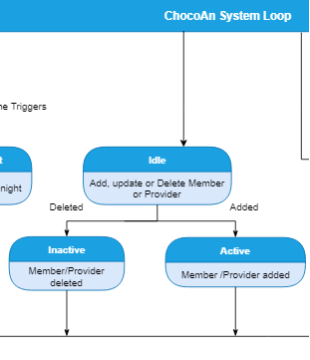

# 

# 

# 

# 

# DFD

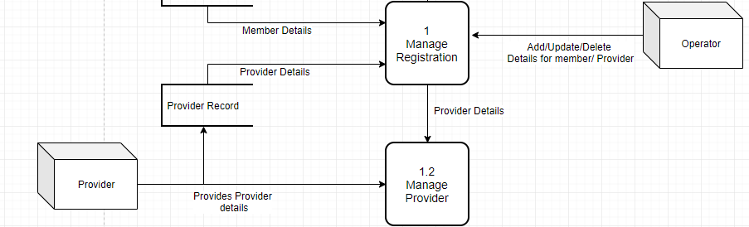

# CLASS DIAGRAM

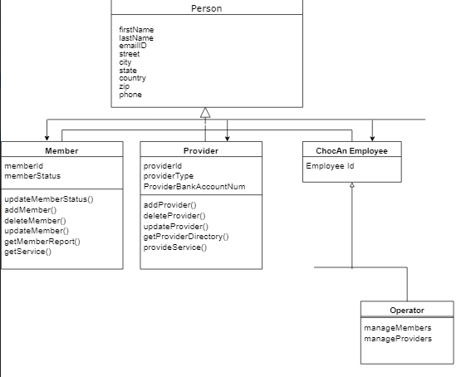

# SEQUENCE DIAGRAM

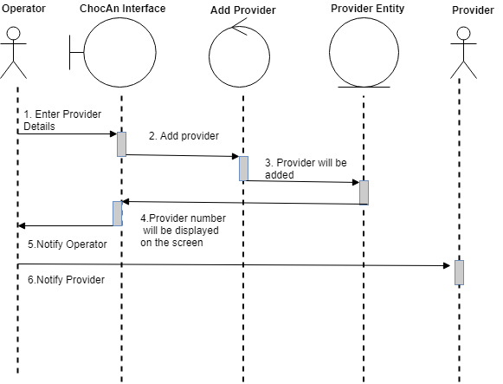

# COMMUNICATION DIAGRAM

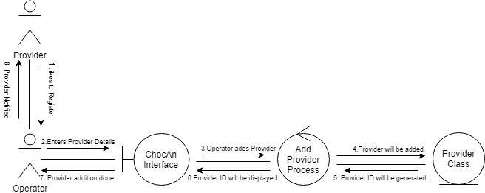

# ROBUSTNESS DIAGRAM

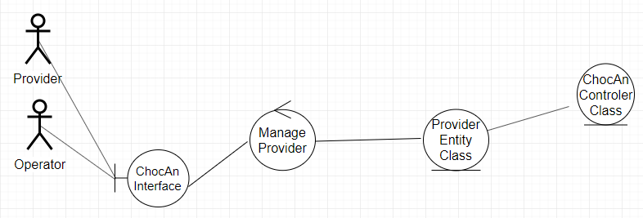

# BUILD ERD

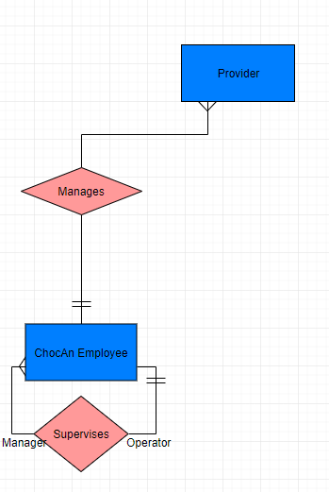

# USE CASE DIAGRAM

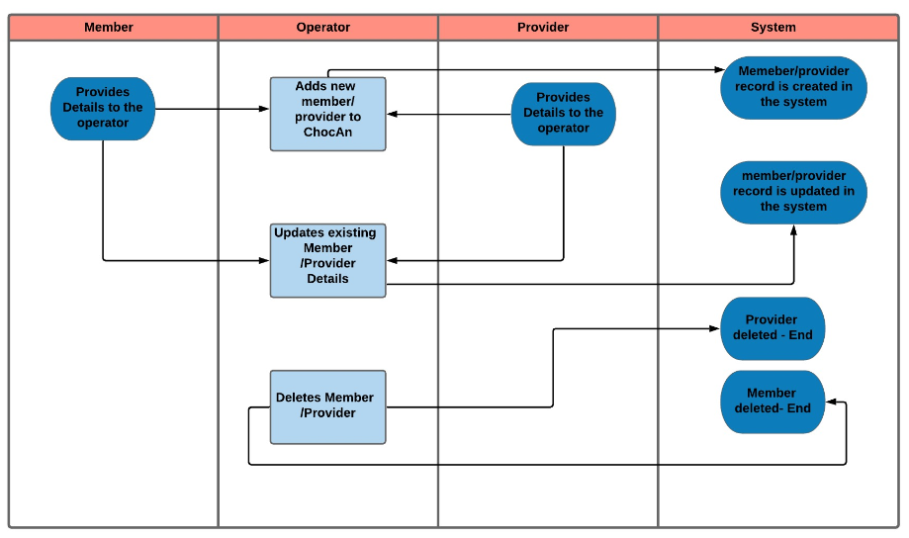

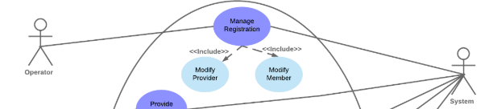

# 

# USE CASE FLOW

* 1. **Add Provider:**
     1. Provider will give the required details like Name, Email address, Phone number, Address to the operator.
     2. Operator will enter the provider details on the terminal and submit.
     3. Provider will be registered and the details of the record will be saved in the ChocAn data center system

.

## 

# 

# 

# 

# 

# 